

North West Regional Transfusion Committee

NORTH WEST TRANSFER POLICY

PROCEDURE FOR THE TRANSFER OF BLOOD AND BLOOD COMPONENTS BETWEEN HOSPITALS

Version 5.0

WRITTEN BY

E Addison, P Baker, D Cain, B Chesterson,
N Fuller, C Gallagher, S Richards

Updated by

Rukhsana Hashmat

Authorised for use by the North West Transfusion Laboratory Managers Working Group

Approved Version 5 – February 2024
Review Date – February 2026

CONTENTS

Contents | Page
1. Introduction | 3
2. Procedure for Dispatching Hospital
Blood/Blood Components Accompanying the Patient | 4
Stock Transfer Between Hospital Transfusion Laboratories | 4
Dispatch of Blood/Blood Components | 4
3. Procedure for Receiving Hospital | 5
4. Appendices
Appendix 1: Hospital Contact Numbers | 6-10
Appendix 2: Blood Component Transfer Form Accompanying Patient | 11
Appendix 3: Stock Transfer Form | 12
Appendix 4: Transit box label Transfer Accompanying Patient | 13
Appendix 5: Transit Box Label for Stock Transfer | 14
Appendix 6: Blood Transfer Advice for Clinical Staff | 15
Appendix 7: Acting on Transferred Blood Components Upon arrival | 16
Appendix 8: Capacity and Transportation Time Limits for NHSBT Transport Box | 17
Appendix 9: NHSBT Phase Change Material (PCM) | 18
Appendix 10: Embedded Electronic Links to Transfer Documents | 19
Appendix 11: Author Information | 20

- Introduction

This document standardises the procedure for the transfer of blood and blood components between hospitals in the North West region. It is a general guide to encompass practices for all users. Hospitals are encouraged to add local protocols to the policy where appropriate but not to detract from the practices outlined in this document.

Principle

Blood and blood components are sometimes transferred between hospitals either with a patient, or as a transfer of blood stocks to prevent wastage.

It is a legal compliance to ensure the audit trail is maintained when blood is transferred and to ensure patient transfusion records are updated accordingly.

Blood and blood components can only be transferred in validated boxes. It is the responsibility of the sending hospital to ensure compliance.

Blood and blood components may be transferred for the following reasons:

1. Blood/blood components allocated to a specific patient may be needed urgently for resuscitation en route or on arrival at the receiving hospital.

2. Agreed transfer of stock between hospital blood transfusion laboratories.

- Procedure for Dispatching Hospital

Blood/Blood Components Accompanying the Patient

- Document telephone call from the requesting hospital with following:
- Patient forename, surname, date of birth and unique ID number
- Details of receiving hospital and ward/unit including the approximate time of departure

- Locate the blood/components to be dispatched.

- Complete a transfer document (appendix 2) including a record of unit donation numbers and make a copy of documentation for your records.

- Return the units to suitable storage conditions whilst preparing the transport box, packing materials and labels.

- Immediately before dispatch, place the blood or blood components and copies of all relevant documents (i.e. transfer documentation) in a suitably sized, validated transport box and cover with appropriate temperature-controlled packs (appendix 8 & 9). Retain a copy of the transfer document.

Note: Blood components should be packaged inside a plastic liner. Do not allow temperature packs to be in direct contact with components.

- Close the transport box lid and seal with a method such as a cable tie to alert receiver if removed or broken the cold chain has been broken. Attach copies of ‘Blood Transfer Advice for Clinical Staff’ (appendix 6) and ‘Acting on transferred blood Components upon arrival’ (appendix 7).
- Attach a completed dispatch label (appendix 4 or 5) and place in the transport box clear pocket (DO NOT DEFACE NHSBT TRANSPORT BOXES).
- Within the Laboratory Information System, the units must be marked as transferred and the destination hospital recorded if possible.

Stock Transfer Between Hospital Transfusion Laboratories

Follow above steps 2, 3, 4, 5, 6 & 8.

Dispatch of Blood/Blood Components

Immediately telephone the receiving blood hospital transfusion laboratory of the dispatch (Contact details appendix 1). State time of dispatch, mode of transport, estimated time of arrival, number and type of units and any antibodies or special requirements. If the blood is accompanying or allocated to a patient, the patient identification details, and the ward or department expected to receive the patient.

- Procedure for Receiving Hospital

- The transfusion laboratory will be informed by the dispatching laboratory of the expected delivery.

- The receiving transfusion laboratory should document the expected delivery and where applicable inform the ward or department receiving the patient that blood will be accompanying the patient.

- Local policies should be in place to ensure received blood and components are transferred to suitable storage facilities as soon as possible.

- On arrival, transfusion laboratory staff should check the integrity of the box and complete the transfer document to verify the units are still under correct storage conditions.

- Any blood or components received in the transfusion laboratory, including any which will be disposed of due to poor storage conditions, must be entered into stock and have their fate recorded.

- The receiving laboratory must ensure that all transferred units are accounted for and their final fate recorded in the Laboratory Information System.

- For blood/components transferred with a patient, the receiving laboratory must inform the dispatching laboratory (by email or fax) of the fate of the units to enable update of patient records as follows; a) Transfused to patient b) Disposed and for what reason c) Not transfused but entered into stock of receiving hospital.

Appendix 1 Contact List

Lancaster Area

Hospital  Name | Address | Transfusion Lab Number | Transfusion Lab Fax Number | Email
Royal Blackburn Hospital | Haslingden Road Blackburn  Lancashire  BB2 3HH | 01254 734 529 | 01254 278 053 | elht.transfusion@nhs.net
Blackpool Victoria Hospital | Whinney Heys Road Blackpool  Lancashire  FY3 8NR | 01253 953 746 | 01253 956 290
Royal Lancaster Infirmary | Ashton Road  Lancaster  Lancashire  LA1 4RP | 01524 583 764 | 01524 583 763
Royal Preston Hospital | Sharoe Green Lane  North Fulwood,  Preston  Lancashire  PR2 9HT | 01772 522 605 | No Fax | RPHtransfusion@lthtr.nhs.uk
Furness General Hospital | Dalton Lane  Barrow-in-Furness  Cumbria  LA14 4LF | 01229 491 276 | 01229 491 256
Burnley General Hospital | Casterton Avenue  Burnley  Lancashire  BB10 2PQ | 01282 804318 |  | elht.transfusion@nhs.net
Westmorland General Hospital | Burton Road  Kendal  Cumbria  LA9 7RG | 01539 795 284 | 01539 795 286

Liverpool Area

Hospital  Name | Address | Transfusion Lab Number | Transfusion Lab Fax Number | Email
Alder Hey Children’s Hospital | Eaton Road  West Derby  Liverpool L12 2AP | 0151 252 5492 |  | transfusion@alderhey.nhs.uk
Arrowe Park Hospital | Arrowe Park Road  Upton Wirral  CH49 5PE | 0151 604 7525 | 0151 604 0034 | Transfusion.aph@nhs.net
Broadgreen Hospital | Thomas Drive  Liverpool  L14 3LB | 0151 282 6740 | 0151 282 6723
Countess of Chester Hospital | Liverpool Road  Chester  CH2 1UL | 01244 365 385 | 01244 365 322
Halton General Hospital | Hospital Way  Runcorn Cheshire  WA7 2DA | 01928 753 046 | 01928 753117 | whh.txrecallwhh@nhs.net
Liverpool Women's Hospital | Crown Street  Liverpool  L8 7SS | 0151 702 4127 | 0151 702 4166
Noble's Isle of Man Hospital | Douglas  Braddan  Isle Of Man  IM4 4QX | 01624 650 630 | 01624 651 315 | NoblesTransfusionTeam@gov.im
Liverpool Heart & Chest Hospital | Thomas Drive  Liverpool  L14 3PE | 0151 228 1616
Nuffield Health The Grosvenor Hospital | Wrexham Road  Chester  CH4 7QP | 01244 674 629 | 01244 671 564
Ormskirk and District General Hospital | Wigan road  Ormskirk  Lancashire  L39 2AZ | 01695 656 645 |  | soh-tr.BloodTransfusion@merseywestlans.nhs.uk
Royal Liverpool University Hospital | Mount Vernon Street Liverpool  L7 8YE | 0151 706 4331 | 0151 706 4030
Southport Hospital | Town Lane  Kew Southport  PR8 6PN | 01704 704 176 |  | soh-tr.BloodTransfusion@merseywestlans.nhs.uk
University Hospital Aintree | Lower Lane  Liverpool  L9 7AL | 0151 529 3415 | 0151 529 2840
Warrington Hospital | Lovely Lane  Warrington  WA5 1QG | 01925 662 547 | 01925 662 007 | whh.txrecallwhh@nhs.net
Whiston Hospital | Warrington Road  Prescot  Merseyside  L35 5DR | 0151 430 1584 |  | soh-tr.BloodTransfusion@merseywestlans.nhs.uk

Manchester Area

Hospital  Name | Address |  |  | Transfusion Lab Number | Transfusion Lab Fax Number | Email
Royal Bolton Hospital |  | Minerva Road  Farnworth  Bolton  BL4 0JR |  | 01204 390 515 | 01204 390 791
Manchester University Foundation Trust |  | Oxford Road  Manchester  M13 9WL |  | 0161 276 4400 | 0161 276 4654
Fairfield General Hospital |  | Rochdale Old Road  Jerico  Bury  Lancashire  BL9 7TD |  | 0161 778 2598 | 0161 763 3802
Leighton Hospital |  | Middlewich Road Leighton  Crewe  CW1 4QJ |  | 01270 612 086 | 01270 612 086
Macclesfield District General Hospital |  | Victoria Road Macclesfield  Cheshire  SK10 3BL |  | 01625 661 808 | 01625 612 967
North Manchester General Hospital |  | Delaunays Road  Crumpsall Way  Manchester  M8 5RB |  | 0161 720 2100 | 0161 720 4615
Royal Albert Edward Infirmary |  | Wigan Lane  Wigan  Lancashire  WN1 2NN |  | 01942 822 145 | 01942 773 665
Salford Royal Hospital |  | Eccles Old Road  Salford  Gtr Manchester  M6 8HD |  | 0161 206 4994 |  | haematology@nca.nhs.uk
Stepping Hill Hospital |  | Poplar Grove  Stockport  SK2 7JE |  | 0161 419 5612 |  | Haematologylab@stockport.nhs.uk
Tameside General Hospital |  |  | Fountain Street  Ashton-Under-Lyne  Gtr Manchester  OL6 9RW | 0161 922 6391 |  | transfusionlab@tgh.nhs.uk
The Christie Hospital |  |  | 550 Wilmslow Road  Withington  Manchester  M20 4BX | 0161 446 3287 | 0161 446 3315
Royal Oldham Hospital |  |  | Rochdale Road  Oldham  Lancashire  OL1 2JH | 0161 627 8372 | 0161 652 0204
Trafford General Hospital |  |  | Moorside Road  Davyhulme  Urmston  Manchester  M41 5SL | 0161 746 2479 | 0161 747 7330
Wythenshawe Hospital |  |  | Southmoor Road  Wythenshawe  Manchester  M23 9LT | 0161 291 2160 |  | Wyth.recall@mft.nhs.uk

Appendix 2 BLOOD / COMPONENT TRANSFER FORM (Accompanying Patient)
Appendix 3 STOCK TRANSFER FORM
Appendix 4 Transit Box Label for Transfer Accompanying Patient
Insert Dispatching Hospital logo here if required

To: Insert name and Address of Receiving Hospital

This box should be taken immediately on arrival to the Hospital Transfusion Laboratory

BLOOD
URGENT
FOR IMMEDIATE DELIVERY

The Blood / Components contained in this box were issued from the Transfusion Laboratory at Insert Hospital here
If found please telephone Insert Number immediately
Packed By:  Signature of BMS  Print Name  Date: Time: | Taken By:  Signature of Person taking box  Print Name  Date: Time
Delivered to:  Signature  Print Name and Designation  Date: Time | Date and time removed from transport box:  Give EXACT time HH:MM
 | Unit 1:
 | Unit 2:
 | Unit 3:
 | Unit 4:
 | Unit 5:
 | Unit 6:
 | Unit 7:
 | Unit 8:
DO NOT open unless immediate transfusion of the patient is indicated
This transport box has been validated for the storage of blood components.
The contents of this box will be suitable for transfusion until
HH:MM hours

Transport box opened / seal broken at: ………………………………………………………………………

In compliance with BSQR 2005, it is confirmed that the contents of this box have been stored securely in accordance with Guidelines for the Blood Transfusion Services.
Appendix 5 Transit Box Label for Stock Transfer

Insert Dispatching Hospital Logo here if required

To: Insert Receiving Hospital Here
BLOOD
URGENT
FOR IMMEDIATE DELIVERY

The Blood / Components contained in this box were issued from the Transfusion Laboratory at Insert Hospital here
If found please telephone Insert Number Here immediately
Packed By:  Signature of BMS  Print Name  Date: Time: | Taken By:  Signature of Person taking box  Print Name  Date: Time

This transport box has been validated for the storage of blood components.
The contents of this box will be suitable for transfusion until
HH:MM hours

In compliance with BSQR 2005, it is confirmed that the contents of this box have been stored securely in accordance with Guidelines for the Blood Transfusion Services.

Appendix 6 Blood Transfer Advice for Clinical Staff

Insert Hospital Logo Here if Required

BLOOD TRANSFER ADVICE FOR CLINICAL STAFF

The blood and blood components have been packed in this transport box following Blood Transfusion Laboratory guidelines

In order to ensure integrity of contents please follow instructions below

During Transfer:

- If blood is required during the patient’s journey please ensure it is checked and transfused in accordance with local policy.

- Please ensure transport box remains sealed unless blood is required for transfusion.
Once opened, the cold chain has been broken and all the units must be transfused within 4 hours

- If blood is removed for transfusion, please replace the lid

- If blood is transfused complete details of date & time against appropriate unit on box lid

- Blood is suitable for transfusion within the timeframe stated on the associated paperwork with the transport box, provided the seal is UNBROKEN

On Arrival:

- When the patient arrives in the receiving clinical area, please ensure the transport box is handed over to the receiving staff member.

- Please state how much blood was transfused during the journey and any adverse events (if occurred)

The responsibility for the blood now lies with the receiving hospital in line with their local policy
Appendix 7 Acting on transferred blood Components upon arrival

ACTING ON TRANSFERRED BLOOD COMPONENTS UPON ARRIVAL
Medical Emergency
Non Emergency
Inform transfusion Laboratory
- Take a blood sample for group and antibody screen

- Request more blood if required
Packed correctly
Blood can be transfused
Ensure that a group & Antibody screen sample has been taken
Not packed correctly
DO NOT TRANSFUSE
Call the Transfusion Laboratory
Send any unused blood and transport box to the transfusion laboratory ASAP
SEND UNOPENED TRANSPORT BOX AND UNUSED BLOOD TO THE TRANSFUSION LAB ASAP
Packed correctly

- Checked documentation and transport box integrity.
If unsure call the Transfusion Laboratory

Not Packed correctly

- Blood arrives in an inadequate container eg Plastic bag, cardboard box
- No time of packing is documented
- Transport seal is broken
- Out of transport time

Appendix 8 Capacity and Transportation Time Limits for NHSBT Transport Box
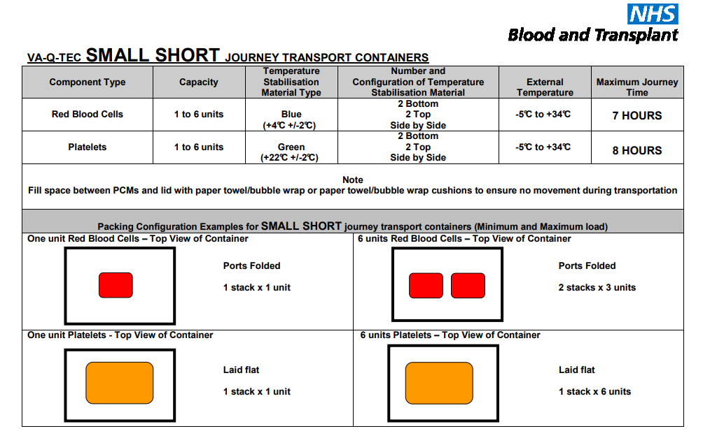
*Includes up to six neo natal units as one adult unit.

Data supplied by NHSBT effective from 14/06/19

Appendix 9 NHSBT Phase Change Material (PCM)

For red cells use blue PCM for transport at 4oC preconditioned at 2-6oC for a minimum of 72 hours. The date and time PCM’s are placed into preconditioning is written on each panel to ensure the minimum time requirements are met.

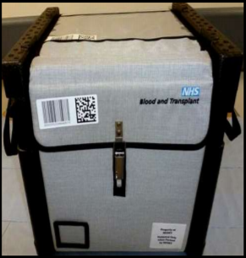
+

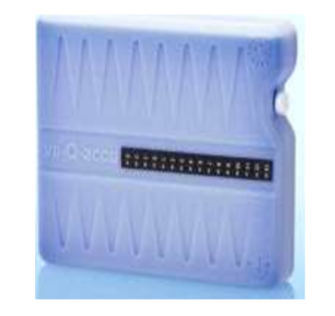

For platelets use green PCM for transport at 22oC±2oC pre-conditioned at 20-24oC for a minimum of 48 hours. The date and time PCM’s are placed into preconditioning is written on each panel to ensure the minimum time requirements are met.

+

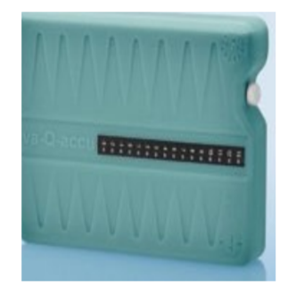

For more information visit: http://hospital.blood.co.uk/components/transport-containers/

Appendix 10 Embedded Electronic links to transfer documents

Note: ‘Printable copies.xlsx’ and ‘Electronic scannable blood stock transfer’ files require Office 2010 or above to open

Appendix 11 Author Information

Elaine Addison, Previous - Transfusion Laboratory Manager,
Blackpool Victoria Hospital

Pete Baker, Service Manager for Transfusion,
Liverpool Clinical Laboratories

Dave Cain, Previous - Operations Manager,
Warrington & Halton Hospitals NHS Foundation Trust

Barry Chesterson, Previous - Senior Specialist Biomedical Scientist,
Warrington & Halton Hospitals NHS Foundation Trust

Neil Fuller, Transfusion Laboratory Manager,
Blackpool Victoria Hospital

Steven Richards, Previous - Transfusion Laboratory Manager,
Stepping Hill Hospital and University Hospital of South Manchester NHS foundation Hospital

Christine Gallagher, NHSBT National Customer Service Manager – Projects and Programmes

Updated by Rukhsana Hashmat NHSBT Customer Service Manager (North West) on behalf of the NW TLM and TP group

Policy Based on: - NHSBT Appropriate Use of Blood Group & National Laboratory Managers’ Group of the CMO’s National Blood Transfusion Committee:
Guidance for the Emergency Transfer of Blood and Components with Patients between Hospitals

Electronic transfer documents developed at Warrington & Halton Hospitals NHS Foundation Trust

