

**NHSBT Essential Transfusion Medicine course – ST3 Laboratory visit checklist**

**A guide for Transfusion Laboratory Managers and Transfusion Practitioners**

NHSBT’s Essential Transfusion Medicine (EMT) course is a 5-day course designed for ST3 (Specialist Training) doctors new into post. The course provides structured digital learning to build a comprehensive understanding of blood transfusion science using theory to case-based exercises.

As part of the transfusion medicine curriculum, ST3s are advised to build a good working relationship with their hospital laboratory staff and to support them with this, we recommend that they visit their hospital transfusion laboratory on the *Thursday afternoon, during the 5 day course. We advise that they liaise with their local laboratory to arrange a visit and give at least **6 weeks’ notice**. *(*If Thursday is not a suitable day for the laboratory, the ST3 is responsible for liaising with the transfusion laboratory manager to reschedule).*

To equip ST3s with the knowledge, skills, and confidence needed to manage transfusions safely and efficiently, while adhering to both laboratory protocols and clinical guidelines, an accompanying practical workbook will be completed by the ST3 during (and as part of) the visit to submit as evidence, as part of their e-portfolio. Although the laboratory visit provides some evidence for the workbook, there may be some further discussions, meetings etc that will require additional sessions.

We appreciate the laboratories help with this visit.

To allow laboratories to prepare for the visit we have provided a checklist of **who and what** will be required for certain parts during the visit. ST3 staff will work through their workbook and may require assistance from different members of staff during this time.

The majority of the practical workbook requires either discussion or direct observation, however the checklist provides a practical list of preprepared items to have ready on the day of the visit. You may be sent a copy of the practical workbook, to be completed by the ST3, as information only.

Some sections of the workbook can be completed without staff involvement and to support this, a user guide is included as part of the workbook. (see below)

**User guide for ST3 workbook**

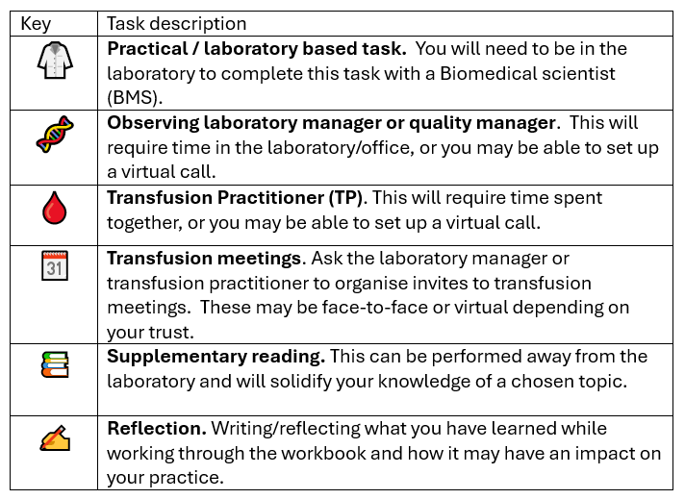

**Checklist for Laboratory Managers, Quality Managers and Transfusion Practitioners.**

|  |  |  |  |
| --- | --- | --- | --- |
| **Task description** | **Who is required** | **Preparation required** | **Tick** |
| 🥼 | Biomedical Scientist | * Details of a recent blood delivery including evidence of the cold chain * Details of an ‘adhoc’ blood request (if available) * Details of the laboratory sample acceptance policy * 2 group and screen samples for manual blood typing (to compare to previous automated results) * Rh/K phenotype being performed * A recent sample referred to RCI and the results * A sample to perform a DAT * Observe/perform a serological crossmatch * Access to the Trust’s Major Haemorrhage Protocol(s) |  |
| 🩸 | Transfusion Practitioner (or Biomedical Scientist) | * Clinical notes for a recent major haemorrhage case (or a BMS who was involved) – access to the type and number of components issued * Access to the local Emergency Blood Management Plan * Actions taken during amber alerts * Incident reporting tools and processes |  |
| 🧬 | Laboratory manager / Quality manager | * Internal incident reporting with corrective and preventative actions (quality management system) * A recent NEQAS report * NEQAS report with points (if available) |  |