Notes for Case Studies:

Cases 1-4:

TACO criteria (simplified)
A | Acute or worsening respiratory compromise
B | Acute or worsening pulmonary oedema
C | Unexplained CV symptoms suggestive of overload
D | Positive fluid balance or improvement with diuresis
E | BNP rise >1.5x
3/5 and either A or B within 12h* of transfusion

TRALI criteria (simplified)
Acute onset hypoxaemia within 6h of transfusion, with imaging evidence of pulmonary oedema, where fluid overload is absent OR not the main contributor AND
Not ARDS (no risk of ARDS or stable pre-tx)

TAD (simplified)
Acute respiratory deterioration within 24h of a transfusion that does not meet TACO/TRALI criteria but appears to be linked to transfusion.
TAD-C – we have enough info
TAD-IC – not enough info

 | Case 1 | Case 2 | Case 3 | Case 4
TACO

TRALI

TAD-C

TAD-IC

Non-tx

Cases 5-7:

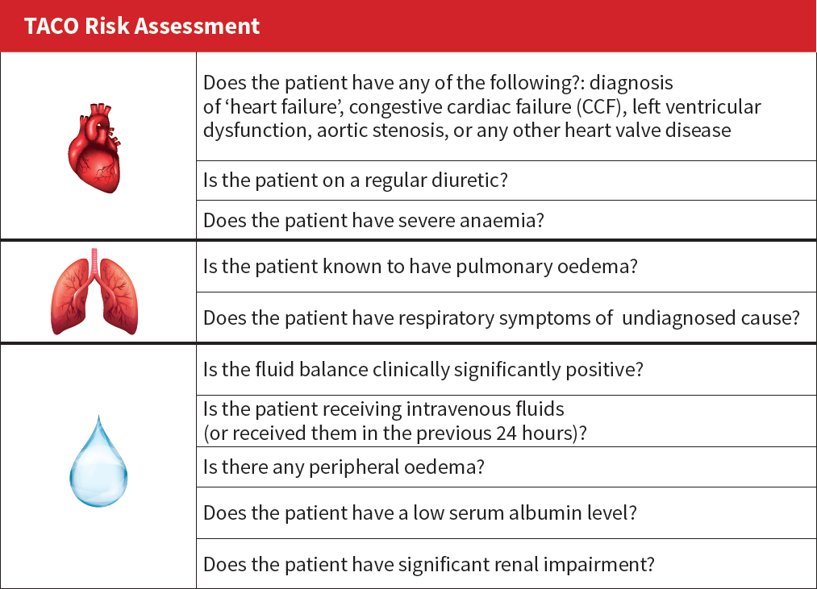

 | Case 5 | Case 6 | Case 7
Heart failure, congestive cardiac failure, LV dysfunction, valve disease
On regular diuretics (or diuretic on hold)
Severe anaemia
Known pulmonary oedema
Undiagnosed respiratory symptoms
Clinically significantly positive fluid balance
IV fluids (current or last 24h)
Peripheral oedema
Low albumin
Renal impairment
Total score

Cases 8-10:

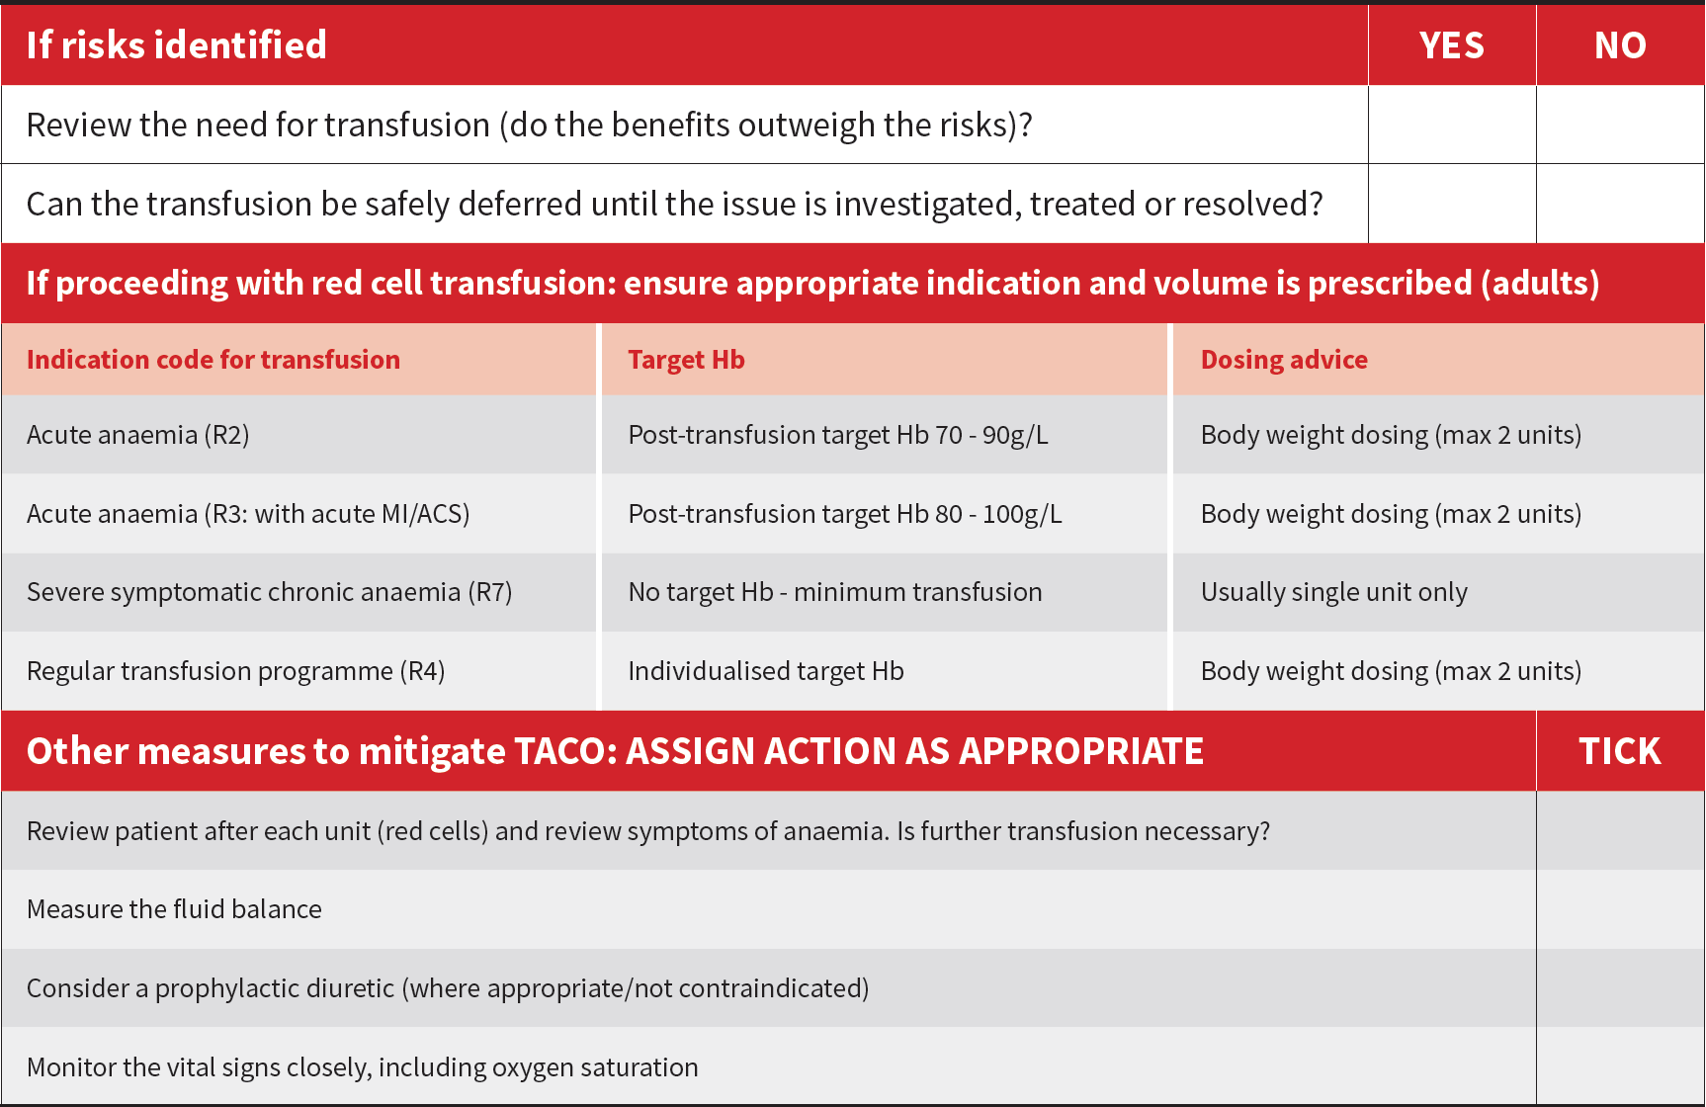

 | Case 8 | Case 9 | Case 10
Transfusion is needed and cannot be deferred | Yes/No | Yes/No | Yes/No
Volume to be transfused | <1 unit  1 unit  2 units  3 or more | <1 unit  1 unit  2 units  3 or more | <1 unit  1 unit  2 units  3 or more
Mitigations | 1  2  3  4 | 1  2  3  4 | 1  2  3  4

