Appendix 1 Proposed RTC and NBTC relationships and accountability/governance relationship

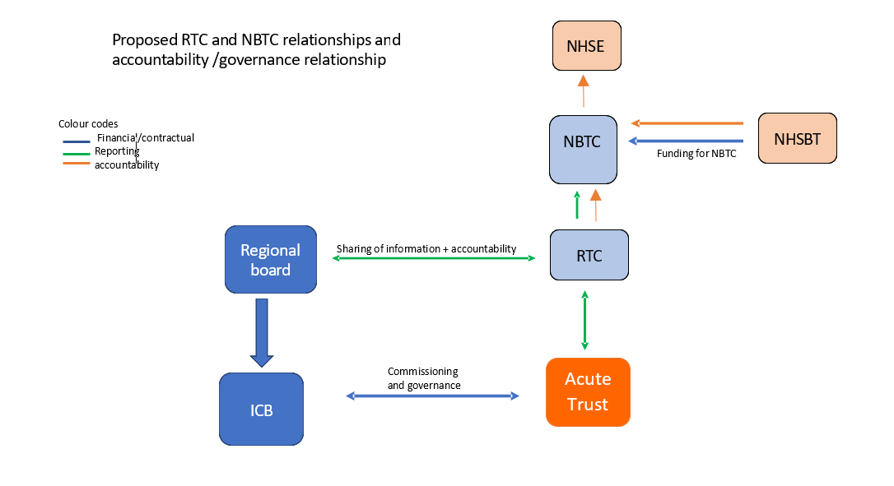

Appendix 2 NBTC/REGIONAL TRANSFUSION COMMITTEE ORGANOGRAM

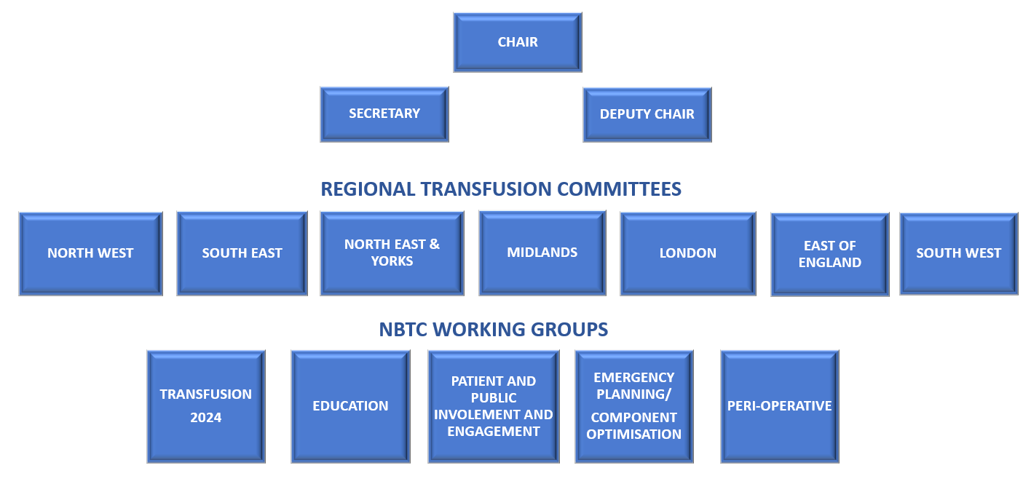

Appendix 3 NCG approved funding for NBTC

In total, 19 PAs have been approved by the NCG to support the activities of the committee. This will allow members to focus more time on the work needed to deliver on NBTC’s objectives and engage with the new NHSE regional structures and Integrated Care Systems to deliver on the Health and Care Act 2022. The split of allocations will be discussed and approved by the Executive Working Group.

For medical and non-medical staff, 1 PA allocation equates to 0.1 wte and so, this equates to 1.9 WTE.

Appendix 4 RTC BUDGET ALLOCATION



Appendix 5 NBTC Terms of Reference Version Control:

|  |  |  |  |
| --- | --- | --- | --- |
| **Version Number** | **Description of Changes** | **Signed off By** | **Sign off Date** |
| **V1** | **Initial Terms of Reference** |  |  |
| **V2** | **Updated NBTC structure and included PA allocation** |  |  |